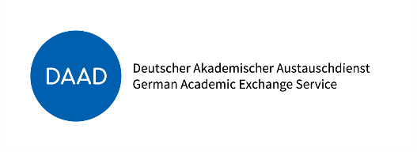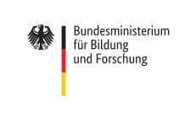
Application for
DAAD PROMOS– Scholarship 2024

(submit to Ms Dagmar Koch)

PROGRAM: ○ Study visit
              - ○ Internship

INSTITUTION: _______________________________________________________

ADDRESS : _______________________________________________________

_______________________________________________________

TIME PERIOD _______________________________________
(from – to / duration in months:

PERSONAL DATA
Name / First Name: | Matriculation No.:
Date of birth / place of birth: | Nationality:
Address: | Contact in case of emergency:
Phone No.: | E-Mail:

UWH STUDY PROGRAM
SINCE: | No. of semesters:
Study program: ____________________________

○ Diploma ○ State Board Examination ○ B.A./B.Sc. ○ M.A./M.Sc.

LANGUAGE SKILLS
Language of host institution:

I am able to attend courses in working language.
○ Yes Level of my language skills:
○ NO _____________________

Proof: ______________________

Do you receive BAföG?
- ○ Yes ○ No
- ○ I submitted application for Auslands-Bafög

Do you already receive or apply for other scholarship?
- ○ No ○ DAAD
- ○ Education Program for Gifted Youth ○ other: _________________________

Any other Notes: …………………………………………………………………………………………..

…………………………………………………………………………………………..

Date / Signature of the applicant

CHECKLIST
- Application form (see download)
- CV
- Letter of Motivation
- Learning Agreement /Training Agreement (see downlaod)
- Letter of Acceptance by host organization
- Expert opinion of UW/H teacher (see download)
- Transkript of Records
- Proof of required language skills (we accept official language certificates such as TOEFEL, IELTS, DEFL, etc., indicating the level (minimum B 1) and DAAD language certificates, not older than 2 years.
- Certificate of enrollment
- Copy of identity card or proof of equality with Germans in accordance with DAAD funding requirements
- Insurance declaration (see download)

